DATA ANALYST INTERNSHIP
Dashboard Creation and Data Visualisation
The Global Food & Nutrition Analytics Dashboard for NutriLine Foods (Project FOODFLOW)
Prepared by: Ayush Yadav
Date: 24 October 2026
Workbook: Dashboard.xlsx (sheets Lists, Calc, and Dashboard added to the Week 3 workbook)
3  Chart types: line, bar, and doughnut (a pie variant) | 5  KPI cards that update live | 3  Dropdown filters: country, year, and metric | 146 to 172  Countries available for each year, 1961 to 2017

About the data
The data is real: FAO food supply per person for 216 countries, regions and groups, 1961 to 2017, the same cleaned dataset used in Weeks 2 and 3. The dashboard uses the 174 current countries only. Figures measure food supply per person, not food eaten.

1. Introduction and Objective

1.1 Context
Weeks 1 to 3 of Project FOODFLOW planned the analysis, cleaned and summarised the data with PivotTables, and automated a routine report with a macro. Week 4 brings that work together in one place: an interactive dashboard that lets a manager explore the data without touching a formula.

1.2 Objective
Build an Excel dashboard that shows key food-supply metrics for virtual food processing, uses several chart types, conditional formatting and dynamic ranges, lets the user filter and drill down with dropdowns, and explains complex data clearly to both technical and non-technical readers.

1.3 How the brief is met
Requirement | How it is met | Section
At least three chart types | A line chart (trend), a horizontal bar chart (top 10 ranking), and a doughnut chart, which is the ring-shaped variant of a pie chart (meat mix). | 6
Conditional formatting | Red/green colouring on the "vs average" card, traffic-light colours on the nutritional status card, plus arrow icons, a top-10 highlight and data bars on the Calc sheet. | 8
Dynamic data ranges | An Excel Table that grows by itself, named ranges, and calculation blocks that rebuild whenever a dropdown changes. | 7
Interactivity | Three dropdowns (country, year, metric) that drive every KPI, chart, and insight. | 7
Key metrics, justified | Five KPI cards, each with a stated reason. | 4
Insights and implications | Five example views with practical conclusions for a food processor. | 9
Documentation and reproducibility | A step-by-step build, a formula reference and a test log. | 5, 10, App.

2. Data Selection

2.1 The dataset
The dashboard uses the FAO Food Balance Sheets "Food supply" dataset (obtained through Our World in Data), which was imported and cleaned in Week 2. It is held in the Excel Table tblFood on the Clean_Data sheet: 11,028 rows, one per entity and year, from 1961 to 2017.

2.2 Why this dataset suits a dashboard
- It is public and real, and it is one of the five sources named in the Week 1 plan.
- It has a time dimension (57 years), a geographic dimension (174 countries), and several measures, so it supports trends, rankings, and breakdowns.
- The earlier weeks already cleaned it and added a Type column (Country, Aggregate, or Historical) and a Nutritional_Status column, so the dashboard can compare countries fairly.

2.3 What the dashboard uses
Item | Column(s) | Unit | Used for
Selectable metrics (7) | Calories_kcal, Protein_g, Meat_kg, Poultry_kg, Milk_kg, Fruit_kg, Veg_kg | kcal or g per day; kg per year | The Metric dropdown feeds the KPI cards, trend chart, and top-10 chart.
Meat types (5) | Bovine_kg, Poultry_kg, Pig_kg, Mutton_kg, OtherMeat_kg | kg per person per year | The doughnut chart.
Status | Nutritional_Status | Text | The status card (based on calories: below 2,100 is Severe Deficit, below 2,500 is Warning, otherwise Adequate).
Filters | Entity, Year, Type | - | Choosing the country and year, and restricting averages and rankings to Type = Country.

Coverage. 146 countries have data in 1961, and 172 in 2017. Nineteen countries start only in 1992 (for example, Armenia), so the dashboard has to handle "no data" cases (Section 7.3).

3. Dashboard Design Plan

3.1 Audience and questions
The audience is the management team of NutriLine Foods: some are comfortable with data, and some are not. The dashboard therefore leads with plain numbers and colours, and keeps the detail one click away. It is built to answer four questions:
- How well supplied is a chosen country on a chosen measure, and how has that changed over time?
- How does it compare with other countries?
- Which countries lead on that measure in a given year?
- What kinds of meat are eaten there, which is a demand signal for processing?

3.2 Design principles
- One screen, one story. Controls at the top, numbers next, then charts, then a written summary.
- Reading order follows the questions: controls, then KPIs, then trend, then ranking, then composition, then insights.
- Colour means something. Red, amber and green are used only for status. Charts use one blue palette so the eye is not distracted.
- White space and large numbers make the KPI cards readable at a glance. Gridlines are switched off.
- Everything is labelled, and chart headings update to say which country, year, and metric are showing.

3.3 Layout
Zone | Location | Content
Header | B1:B2 | Title and subtitle.
Controls | F5:L6 | Three dropdowns: Country (F6), Year (I6), Metric (L6).
KPI row | Rows 9 and 10 | Five cards: metric value, country average, vs average, global rank, and nutritional status, with a small label under each.
Trend chart | Left, rows 13 to 33 | Line chart: selected country against the average of all countries.
Ranking chart | Right, rows 13 to 34 | Bar chart: top 10 countries for the chosen metric and year.
Composition chart | Bottom left, rows 38 to 58 | Doughnut chart: the meat mix of the selected country and year.
Key Insights | Bottom right, from J36 | A text box that writes three sentences about the current selection.

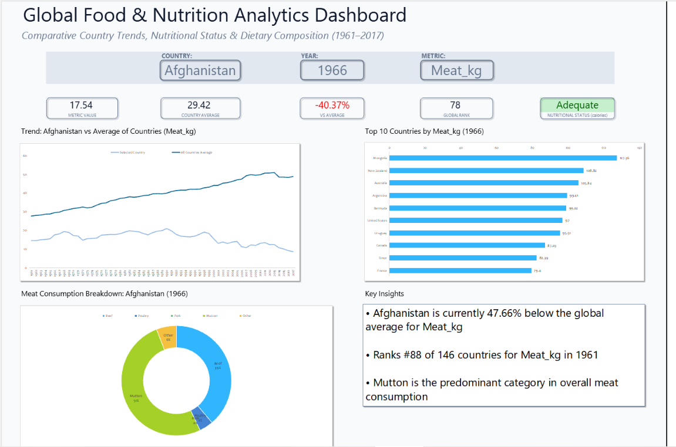
Layout sketch of the dashboard
Figure 1. The planned layout.

4. Key Performance Indicators
Each KPI answers a question a manager would ask in the first ten seconds. The five cards sit in one row, in the order the questions are asked.
KPI card | Cell | Formula (on the Calc sheet) | Why it was chosen
Metric value | C9 | Calc!N2 (named Value): the SUMIFS of Metric_Value for the chosen country and year. | The headline number: what is the supply here, in this year?
Country average | F9 | Calc!N3 (named Average): AVERAGEIFS of Metric_Value for all countries in that year. | A number means little without a yardstick.
Vs average | I9 | Calc!N4: Value / Average - 1. | Turns two numbers into one signed percentage that anyone can read.
Global rank | L9 | Calc!N5: 1 + the count of countries with a higher value. | A rank is the easiest comparison for a non-technical reader.
Nutritional status (calories) | O9 | Calc!N6: the Nutritional_Status of that country and year. | A traffic-light signal that connects the dashboard to the Week 3 screening rule.

Two wording points. "Country average" is the simple average of all countries with data that year (each country counts equally), and "global rank" means rank among those countries (146 to 172 depending on the year). The status always comes from calories, whichever metric is chosen, which is why its label says "(calories)".

5. Building the Dashboard, Step by Step
The dashboard was built in a copy of the Week 3 workbook, so the Raw_Data sheet stays untouched. Three sheets were added: Lists (choices for the dropdowns), Calc (all calculations), and Dashboard (what the reader sees).

Step 1: Create the lists and name them
- Lists!A holds the 174 country names (copied from Entity_Types after filtering Type to Country). Lists!B holds the years 1961 to 2017, and Lists!C holds the seven metric names exactly as they appear in the table headers.
- Each list was named with the Name Box so formulas stay readable.
Name | Range | Contents
lstCountry | Lists!$A$2:$A$175 | 174 country names
lstYear | Lists!$B$2:$B$58 | Years 1961 to 2017
lstMetric | Lists!$C$2:$C$8 | Calories_kcal, Protein_g, Meat_kg, Poultry_kg, Milk_kg, Fruit_kg, Veg_kg

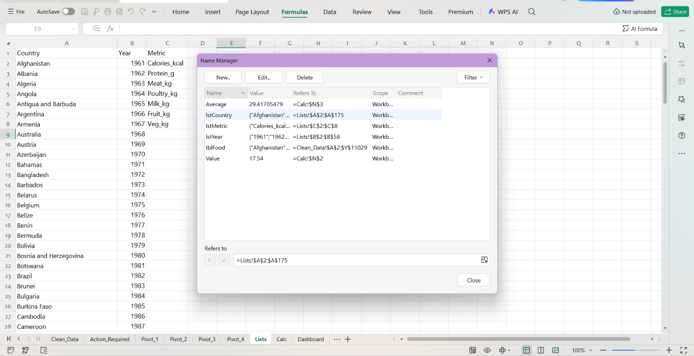
Lists sheet and the Name Manager
Figure 2. The lists and their names.

Step 2: Add the dropdown controls
On the Dashboard sheet, cells F6, I6, and L6 were turned into dropdowns with Data, Data Validation, Allow: List, using the three names as sources (=lstCountry, =lstYear, =lstMetric). The starting selection is Afghanistan, 1966, Meat_kg.
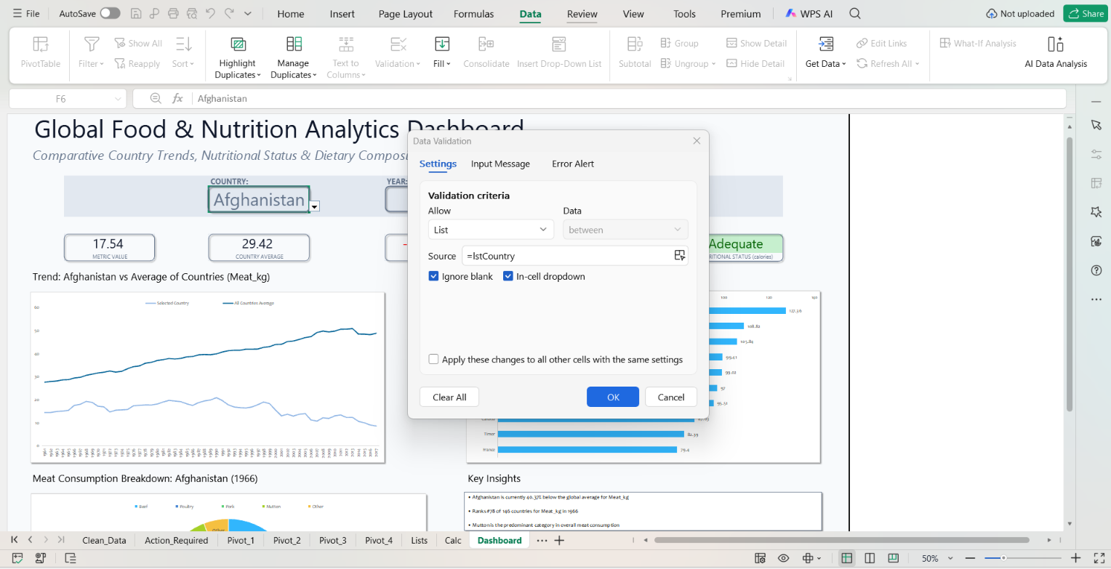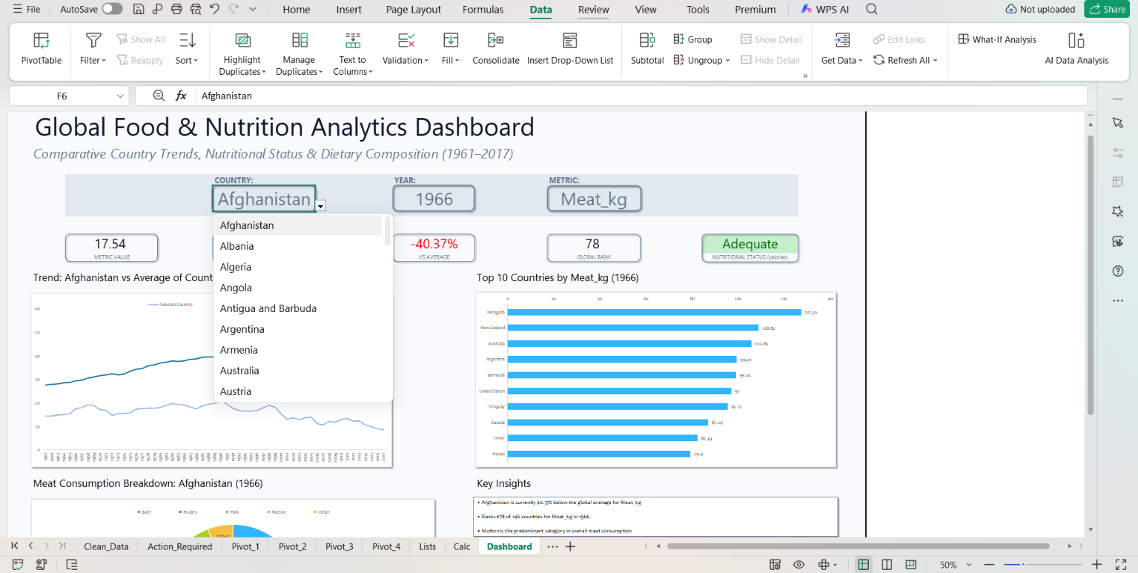
Data Validation dialog and an open dropdown
Figure 3. The dropdown controls.

Step 3: Add two helper columns to the table
Two columns were added to the right of tblFood. They are what make the dashboard respond to the dropdowns.
Metric_Value:
=IFERROR(INDEX(tblFood[[#This Row],[Calories_kcal]:[Veg_kg]],
MATCH(Dashboard!$L$6, tblFood[[#Headers],[Calories_kcal]:[Veg_kg]], 0)), "")

Rank_Key:
=IF(AND(tblFood[[#This Row],[Type]]="Country", tblFood[[#This Row],[Year]]=Dashboard!$I$6,
ISNUMBER(tblFood[[#This Row],[Metric_Value]])), tblFood[[#This Row],[Metric_Value]] + ROW()/1000000000, "")

- Metric_Value looks at the metric chosen in L6 and returns that column's value for every row. When the dropdown changes, the whole column changes.
- Rank_Key keeps a number only for country rows in the chosen year. The tiny ROW() term makes every key unique, so two countries with the same value never tie in the top 10.
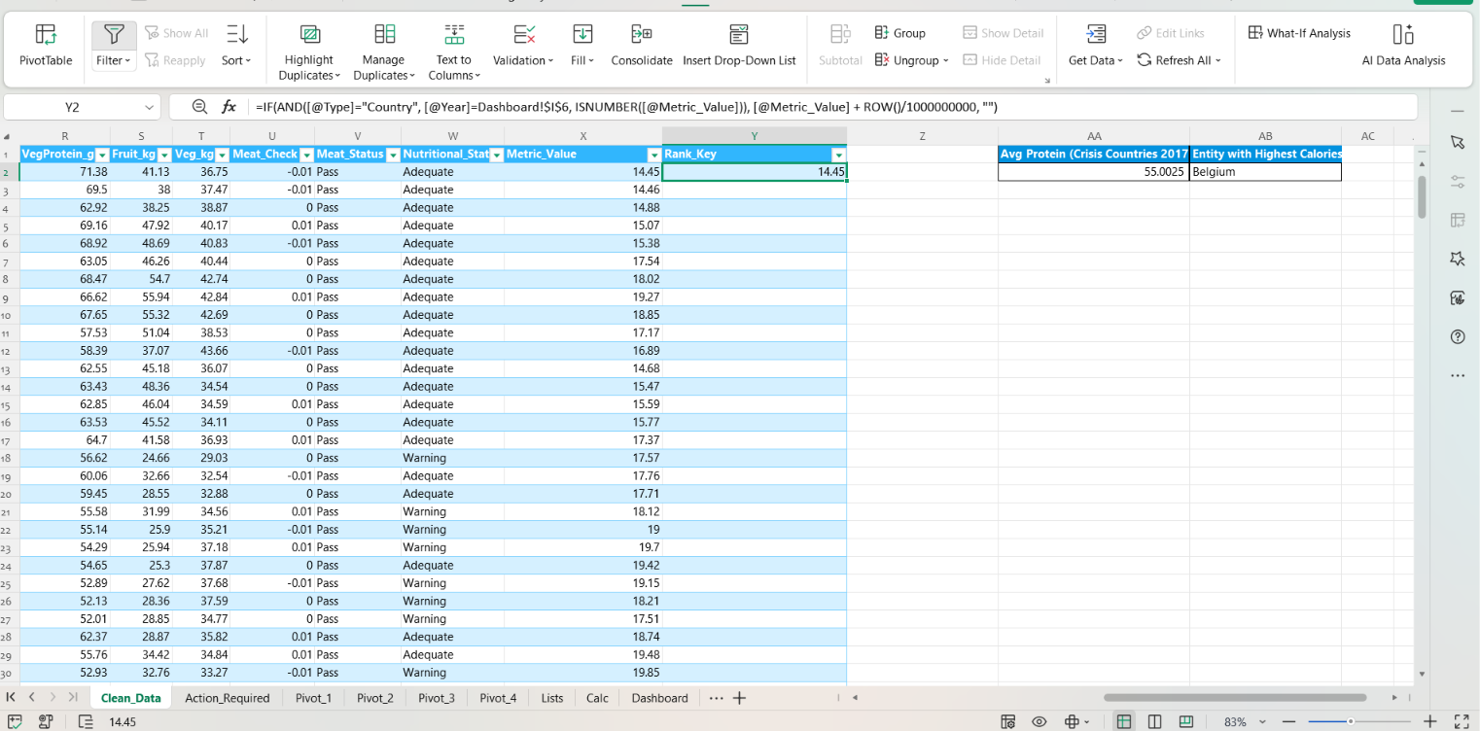
The two helper columns in tblFood
Figure 4. Helper columns that connect the table to the dropdowns.

Step 4: Build the calculation blocks on the Calc sheet
Block | Location | What it holds
KPI block | M1:N6 | Value, Average, Difference, Rank, and Status. N2 and N3 are named Value and Average, so N4 reads =Value/Average-1.
Trend data | A1:C58 | Years 1961 to 2017, the selected country's value (column B) and the all-country average (column C).
Top 10 data | E1:H11 | Rank 1 to 10, the sort key, the country name, and its value.
Doughnut data | J1:K6 | The five meat types and their kg for the selected country and year.
Insight text | Q1:R13 | Helper cells and the three insight sentences, joined into R13.

Trend, selected country (B2):
=IFERROR(AVERAGEIFS(tblFood[Metric_Value], tblFood[Entity], Dashboard!$F$6, tblFood[Year], A2), NA())
Trend, all countries (C2):
=IFERROR(AVERAGEIFS(tblFood[Metric_Value], tblFood[Type], "Country", tblFood[Year], A2), NA())
Top 10 (F2, G2, H2):
=LARGE(tblFood[Rank_Key], E2)
=INDEX(tblFood[Entity], MATCH(F2, tblFood[Rank_Key], 0))
=INDEX(tblFood[Metric_Value], MATCH(F2, tblFood[Rank_Key], 0))
Doughnut, beef (K2):
=SUMIFS(tblFood[Bovine_kg], tblFood[Entity], Dashboard!$F$6, tblFood[Year], Dashboard!$I$6)

- NA() in the trend columns makes the chart skip a missing year instead of drawing a false zero.
- The top 10 uses LARGE to pick the k-th biggest key, then INDEX/MATCH to look up the country and its value.
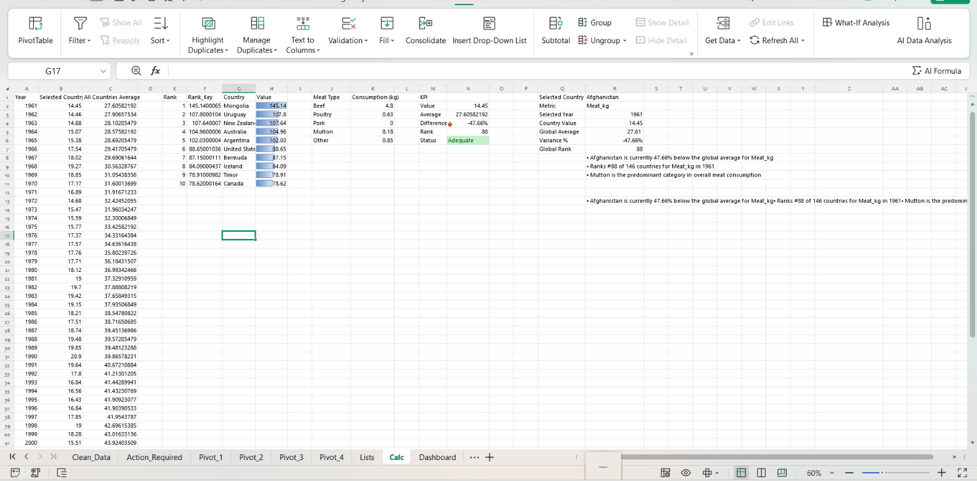
The Calc sheet
Figure 5. The Calc sheet.

Step 5: Insert the charts
Chart | Source on Calc | How it was inserted
Line chart | A2:A58 (years), B (selected country), C (average) | Select the three columns, then Insert, then Line. Legend at the top.
Bar chart | G2:G11 (countries), H2:H11 (values) | Insert, then Clustered Bar. Data labels on, no legend.
Doughnut chart | J2:J6 (meat types), K2:K6 (kg) | Insert, then Doughnut. Percentage labels on, legend at the top.

Each chart was then cut and pasted onto the Dashboard sheet and sized to fit its zone. The default chart titles were removed and replaced by headings in cells (Step 7), because a cell can build its text from the dropdown choices and a chart title cannot.
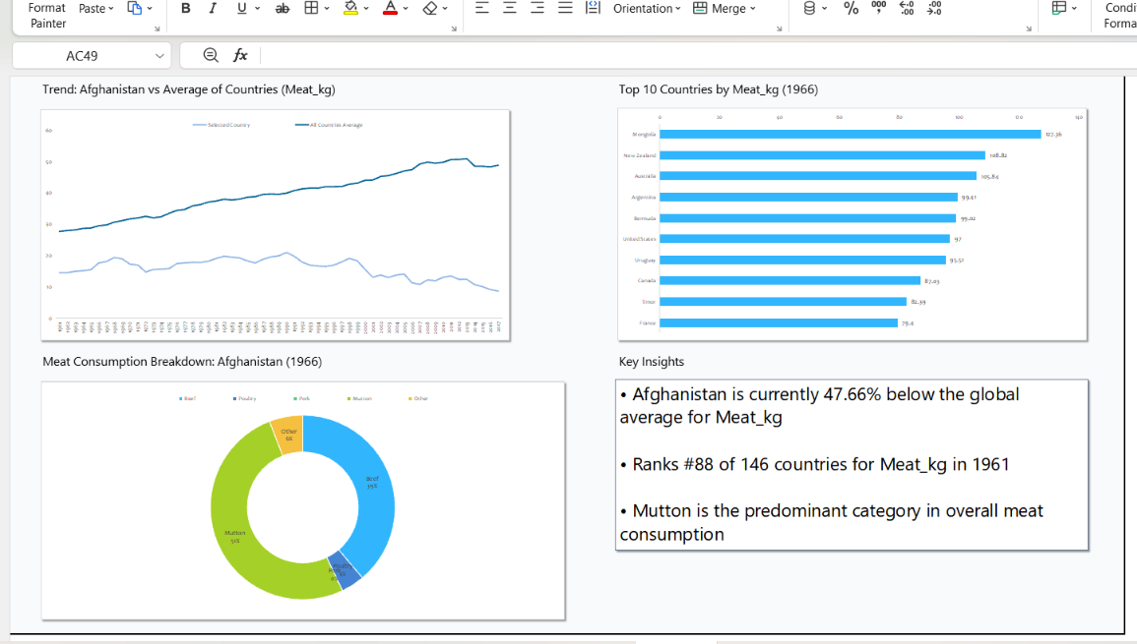
The three charts on the Dashboard
Figure 6. The three charts.

Step 6: Build the KPI cards
Five rounded rectangles sit behind cells C9, F9, I9, L9 and O9. Each cell is linked to the KPI block (for example, C9 is =Calc!N2) and is formatted with a large font and the right number format (two decimals for values, percent for the difference). A small label in row 10 sits under each card.

Step 7: Add dynamic headings and the Key Insights panel
Headings above the charts are formulas, so they always describe what is shown:
B12: ="Trend: " & F6 & " vs Average of Countries (" & L6 & ")"
J12: ="Top 10 Countries by " & L6 & " (" & I6 & ")"
B36: ="Meat Consumption Breakdown: " & F6 & " (" & I6 & ")"

The Key Insights box is a text box whose text is linked to cell Calc!R13. That cell joins three sentences, built by formulas (Section 7.4), so the box rewrites itself whenever a dropdown changes.

Step 8: Add conditional formatting
Colour rules were added to the status card, the "vs average" card, and several Calc cells (Section 8).

Step 9: Final polish
- Gridlines were switched off (View, untick Gridlines) and the zoom was set to 75% so the whole dashboard fits on one screen.
- Titles, labels, and fonts were made consistent, and the charts were aligned to the cell grid.
The finished dashboard (default view)
Figure 7. The finished dashboard.

6. Visual Components and Why They Were Chosen
Component | Data and settings | Why this type | How it responds
Line chart | Two lines over 1961 to 2017: Selected Country (Calc!B) and All Countries Average (Calc!C). Legend at the top. Gaps for missing years. | Lines are the clearest way to show change over time, and two lines allow an instant comparison. | Redraws when the country or metric changes.
Horizontal bar chart | Top 10 countries (Calc!G and H). Clustered bars, value labels, no legend. | Long country names read better on horizontal bars, and bar length is the easiest way to compare sizes in a ranking. | Redraws when the year or metric changes.
Doughnut chart | Five meat types (Calc!J and K) with percentage labels. Legend at the top. | It shows parts of a whole. It is kept to five slices so it stays readable, and the percentages make exact comparison possible. | Redraws when the country or year changes.
KPI cards | Five linked cells with rounded backgrounds and small labels. | Large numbers give the answer at a glance before any chart is read. | Update with every dropdown.
Key Insights box | A text box linked to Calc!R13. | Plain-language sentences help non-technical readers. | Rewrites itself for every selection.
Dynamic headings | Cells B12, J12 and B36. | They tell the reader exactly which country, year, and metric they are looking at. | Rebuild from the dropdowns.

Why not other chart types?
- A pie for the trend or the ranking would be unreadable: pies suit a few parts of one whole, not 57 years or ten countries.
- A line for the top 10 would suggest the countries are in a sequence, which they are not.
- A table only would hold the same numbers, but the pattern would be much harder to see.
The brief mentions a pie chart. A doughnut is the ring-shaped version of a pie chart, using the same data and the same reading, so it serves the same purpose.

7. Interactivity and Dynamic Ranges

7.1 The three dropdowns
Control | Cell | Source list | What it changes
Country | F6 | lstCountry (174) | The selected-country line, the value, status, and rank cards, the doughnut, and the insights.
Year | I6 | lstYear (1961 to 2017) | The KPI values, the top 10, the doughnut, and the insights.
Metric | L6 | lstMetric (7 measures) | The KPI values, both lines, the top 10, and the insights.

7.2 What happens when a dropdown changes
- The user picks a value in F6, I6, or L6.
- Excel recalculates the helper columns in tblFood: Metric_Value switches to the chosen column, and Rank_Key keeps only the chosen year's countries.
- The Calc blocks recalculate from those columns: the KPI block, the trend lines, the top 10, and the meat mix.
- The cards, charts, headings, and Key Insights box read from Calc and update on screen. No macro is needed.

7.3 The dynamic ranges
Dynamic element | How it works
Excel Table (tblFood) | Formulas refer to column names such as tblFood[Metric_Value]. When rows are added to the table, every formula and chart that depends on it includes them automatically.
Named ranges | lstCountry, lstYear, and lstMetric feed the dropdowns, and Value and Average name two KPI cells so that formulas read like sentences.
Switching column (INDEX/MATCH) | Metric_Value picks a different column of the table depending on the Metric dropdown, so one set of charts serves seven measures.
Top 10 by LARGE | The top-10 block always shows the ten highest values for whichever year and metric are chosen.
Gaps with NA() | A year with no data is skipped by the chart instead of being drawn as zero.
"No data" handling | If the chosen country has no data in the chosen year (for example, Armenia in 1966), the KPI cards show "No data" and the Key Insights box says so instead of showing an error.

7.4 How the Key Insights sentences are built
R8 : ="• " & country & " is currently " & TEXT(ABS(variance),"0.00%") & IF(variance<0," below "," above ")
& "the global average for " & metric
R9 : ="• Ranks #" & rank & " of " & COUNTIFS(Type,"Country",Year,year) & " countries for " & metric & " in " & year
R10: finds which of the five meat types is largest for that country and year, and writes
"• Mutton is the predominant category in overall meat consumption"
R13: =IF(ISNUMBER(N2), R8 & CHAR(10) & CHAR(10) & R9 & CHAR(10) & CHAR(10) & R10,
"• No " & metric & " data reported for " & country & " in " & year & ". Select another year.")
R4 to R7 on the Calc sheet calculate the country value, average, variance, and rank a second way, using the dynamic array functions FILTER and XLOOKUP, and R8 to R10 reuse them. For the saved view, both methods give the same answers (value 17.54, variance -40.37%, rank 78), which is a built-in cross-check (Section 10). The dynamic array functions (FILTER, XLOOKUP, CHOOSECOLS) need Excel 365, Excel 2021, or Excel for the web.
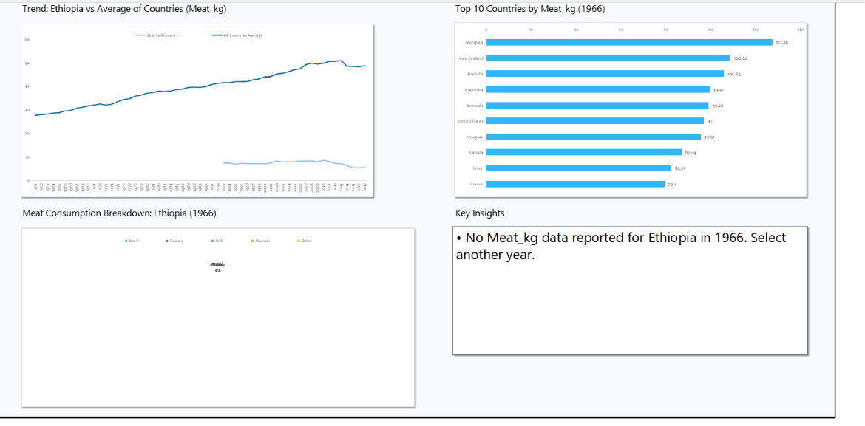
The Key Insights box for two different selections
Figure 8. Key Insights text.

8. Conditional Formatting
Where | Range | Rule | Purpose
Dashboard | I9 (vs average) | Red font if the value is below 0. Dark green font if it is 0 or more. | The reader sees at once whether the country is below or above the average.
Dashboard | O9 (status) | Text contains "Severe": red text on a pink fill. "Warning": amber text on a yellow fill. "Adequate": green text on a green fill. | A traffic light for nutritional status.
Calc | N4 | Icon set of three arrows, split at 0. | Arrow direction shows above or below average.
Calc | N5 (rank) | Gold fill with bold text if the rank is below 11. | Highlights top-10 countries.
Calc | N6 (status) | Same three text rules as O9. | Keeps the source cell consistent with the card.
Calc | H2:H11 (top 10) | Data bars, blue. | Shows relative size inside the table that feeds the bar chart.

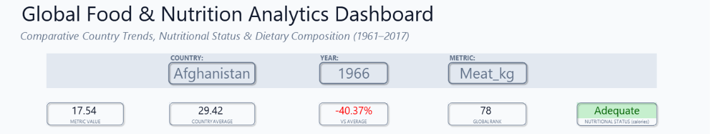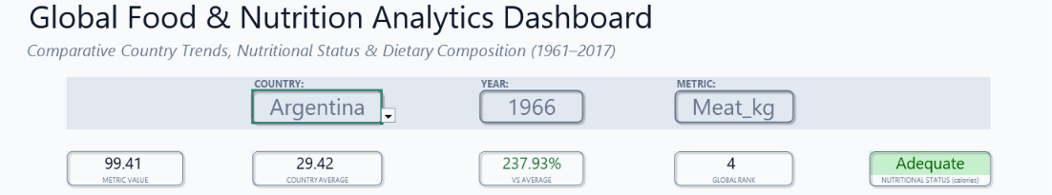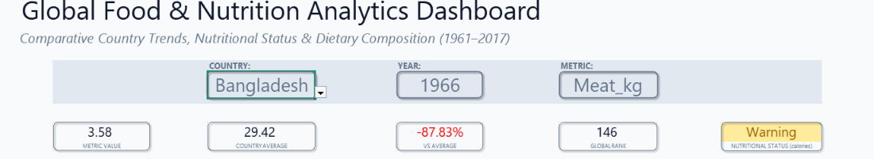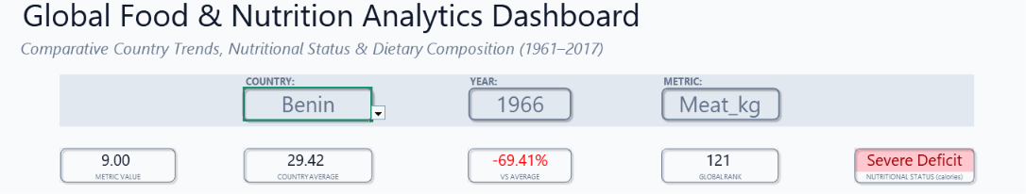
Conditional formatting in action
Figure 9. Conditional formatting on the dashboard.
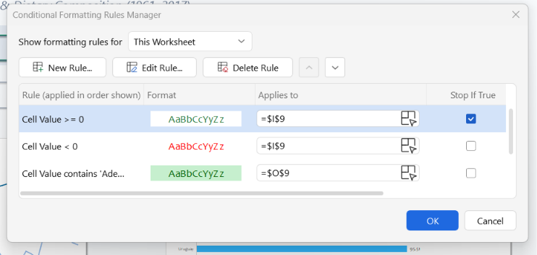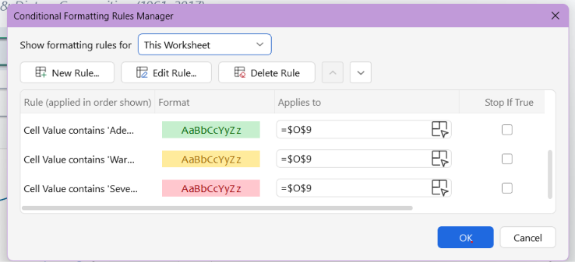
Manage Rules dialog
Figure 10. The rule list.

9. Insights and Practical Implications for Food Processing
Five views were chosen to show what the dashboard can tell a food processor. All numbers below are read directly from the dashboard for the stated selection.

9.1 Afghanistan, 1966, Meat_kg (the saved view)
KPI | Value | KPI | Value
Metric value | 17.54 kg | Global rank | 78 of 146
Country average | 29.42 kg | Status (calories) | Adequate (2,737 kcal)
Vs average | -40.37% | Biggest meat type | Mutton (51.2%)

- The gap has widened. Afghanistan's meat supply was 52% of the country average in 1961 (14.45 kg against 27.61 kg), and only 18% in 2017 (8.59 kg against 48.75 kg). The average rose by 77% while Afghanistan's fell by 41%.
- The mix is mutton-led: mutton 51.2%, beef 38.8%, other 5.9%, poultry 4.1%, no pork reported.
- The 1966 top 10 is led by Mongolia (127.36 kg), New Zealand (108.82), Australia (105.84), Argentina (99.41), and Bermuda (99.02): countries known for large livestock sectors.
Implication. Using the global average as a target would overstate demand for processed meat in markets like this one. A processor entering it should plan for small volumes, a mutton-based product mix, and low price points.

9.2 Algeria, Milk_kg, 1964 against 2017
 | 1964 | 2017 | Change
Milk supply per person | 38.94 kg | 121.71 kg | 3.1 times higher
Country average | 76.49 kg | 101.32 kg | +32%
Vs average | -49.09% | +20.13% | from below to above
Global rank | 86 of 146 | 57 of 172 | up 29 places
Nutritional status | Severe Deficit (1,540 kcal) | Adequate (3,349 kcal) | Two status levels up

Implication. Algeria shows a market that moved from food scarcity to an above-average dairy supply in one generation. For a processor, this is the profile of a growing dairy demand market: UHT milk, powdered milk, and long-shelf-life dairy products fit a market that is still building its cold chain.

9.3 Brazil, Poultry_kg, 1961 against 2017
 | 1961 | 2017 | Change
Poultry supply per person | 1.73 kg | 48.03 kg | 27.8 times higher
Country average | 2.74 kg | 20.22 kg | 7.4 times higher
Global rank | 69 of 146 | 11 of 172 | up 58 places

Implication. Poultry is the fastest-growing meat. The average rose 7.4 times, and leading countries rose much further. This supports adding poultry processing capacity (slaughter, cutting, portioning and packaging), consistent with the Week 2 finding that poultry went from 10% to 41% of meat supply. In 2017, the top of the poultry ranking is held by Saint Vincent and the Grenadines (72.3 kg), Israel (67.4 kg), Samoa (64.8 kg), Saint Lucia (56.7 kg) and Saint Kitts and Nevis (55.8 kg), so even among leaders there is wide variation.

9.4 All countries, Calories_kcal, 2017
Country | Calories per person per day | What the dashboard shows
Belgium | 3,768 | Rank 1 of 172 (top of the bar chart)
United States | 3,766 | Rank 2
Ireland | 3,717 | Rank 3
Algeria | 3,349 | Rank 32 of 172, +17.11% against an average of 2,859.78, Adequate
Central African Republic | 1,758 | Rank 172 of 172, -38.53% against the average, Severe Deficit in red

Implication. The same dashboard shows two very different market types. High-supply markets such as Belgium and the United States compete on quality and variety. Low-supply markets such as the Central African Republic need affordable, shelf-stable, fortified products. This is the same screening idea as the Week 3 action report, now visible in one view.

9.5 India, 2017: switching the metric
Metric | India | Country average | Rank
Meat_kg | 3.78 kg | 48.75 kg | 172 of 172 (-92.25%)
Milk_kg | 106.06 kg | 101.32 kg | 67 of 172 (+4.68%)

Implication. India has the lowest meat supply per person of all 172 countries, yet an above-average milk supply. A processor should not assume that low meat demand means low protein demand: the product mix has to follow local eating patterns. The metric dropdown lets a manager test this in seconds.

9.6 Summary: what this means for NutriLine Foods
Finding | Evidence from the dashboard | Practical implication
Poultry is growing fastest | Average 2.74 to 20.22 kg; Brazil 1.73 to 48.03 kg | Prioritise poultry processing lines.
Transition markets grow dairy demand | Algeria milk 3.1 times higher; status from Severe Deficit to Adequate | Offer shelf-stable dairy for markets building cold chains.
Markets are diverging | Afghanistan fell from 52% to 18% of the meat average | Set targets by market, not by the global average.
Markets sit in tiers | Belgium 3,768 kcal against Central African Republic 1,758 kcal | Premium and variety in rich markets; affordable fortified staples in the poorest.
Local mix matters | India: lowest meat rank, above-average milk | Check several metrics before choosing product lines.

10. Testing and Validation

10.1 Approach
Three kinds of checks were used. Built-in cross-checks in the workbook calculate the same figures by two routes. Independent recalculation rebuilt each result separately from the table data. Scenario tests change the dropdowns and compare what appears with the expected values.

10.2 Built-in cross-check
The Calc sheet calculates the country value, the average, the variance, and the rank twice: once with SUMIFS, AVERAGEIFS, and COUNTIFS (cells N2 to N5), and once with FILTER and XLOOKUP (cells R4 to R7). For the saved view, the two routes agree: variance -40.37% and rank 78 both ways.

10.3 Independent recalculation
For the saved view, the metric value (17.54), the country average (29.42), the variance (-40.37%), the rank (78 of 146), the top ten countries and values, and the five meat-type values were all recalculated separately from the table data and matched the dashboard exactly. The expected values in the scenario tests below were calculated the same way.

10.4 Scenario tests
Run each test by changing the dropdowns and complete the yellow Observed column.
# | Selection | Expected result | Observed
T1 | Afghanistan, 1966, Meat_kg | Value 17.54, average 29.42, -40.37%, rank 78 of 146, Adequate. Top bar: Mongolia 127.36. Doughnut: beef 6.81, poultry 0.72, pork 0, mutton 8.98, other 1.03. | Value 17.54, average 29.42, -40.37%, rank 78 of 146, Adequate. Top bar: Mongolia 127.36. Doughnut: beef 6.81, poultry 0.72, pork 0, mutton 8.98, other 1.03.
T2 | Algeria, 1964, Milk_kg | 38.94, 76.49, -49.09% in red, rank 86 of 146, Severe Deficit in red. | Value 38.94, average 80.62, -51.70% in red, rank 86 of 146, Severe Deficit in red.
T3 | Algeria, 2017, Milk_kg | 121.71, 101.32, +20.13% in green, rank 57 of 172, Adequate in green. | Value 121.71, average 101.32, +20.13% in green, rank 57 of 172, Adequate in green.
T4 | Central African Republic, 2017, Calories_kcal | 1,758, 2,859.78, -38.53%, rank 172 of 172, Severe Deficit. Top bars: Belgium 3,768, United States 3,766, Ireland 3,717. | Value 1,758, average 2,859.78, -38.53%, rank 172 of 172, Severe Deficit. Top bars: Belgium 3,768, United States 3,766, Ireland 3,717.
T5 | Brazil, 1961, Poultry_kg | 1.73, 2.74, -36.79%, rank 69 of 146, Warning. | Value 1.73, average 2.85, -39.31%, rank 69 of 146, Warning.
T6 | Brazil, 2017, Poultry_kg | 48.03, 20.22, +137.58%, rank 11 of 172, Adequate. | Value 48.03, average 20.22, +137.58%, rank 11 of 172, Adequate.
T7 | India, 2017, Meat_kg then Milk_kg | Meat 3.78, 48.75, -92.25%, rank 172 of 172. After switching: Milk 106.06, 101.32, +4.68%, rank 67 of 172. | Meat 3.78, average 48.75, -92.25%, rank 172 of 172. After switching to Milk: Milk 106.06, average 101.32, +4.68%, rank 67 of 172.
T8 | Armenia, 1966, Meat_kg (no data) | Value, vs average, rank, and status show "No data". Key Insights says no Meat_kg data was reported for Armenia in 1966. The trend line starts in 1992. | Value, vs average, rank, and status show "No data". Key Insights says no Meat_kg data was reported for Armenia in 1966. The trend line starts in 1992.
T9 | Change the metric only | The line chart, bar chart, heading, KPI cards, and insights all change. The doughnut stays the same because it always shows meat types. | The line chart, bar chart, heading, KPI cards, and insights all change. The doughnut stays the same because it always shows meat types.

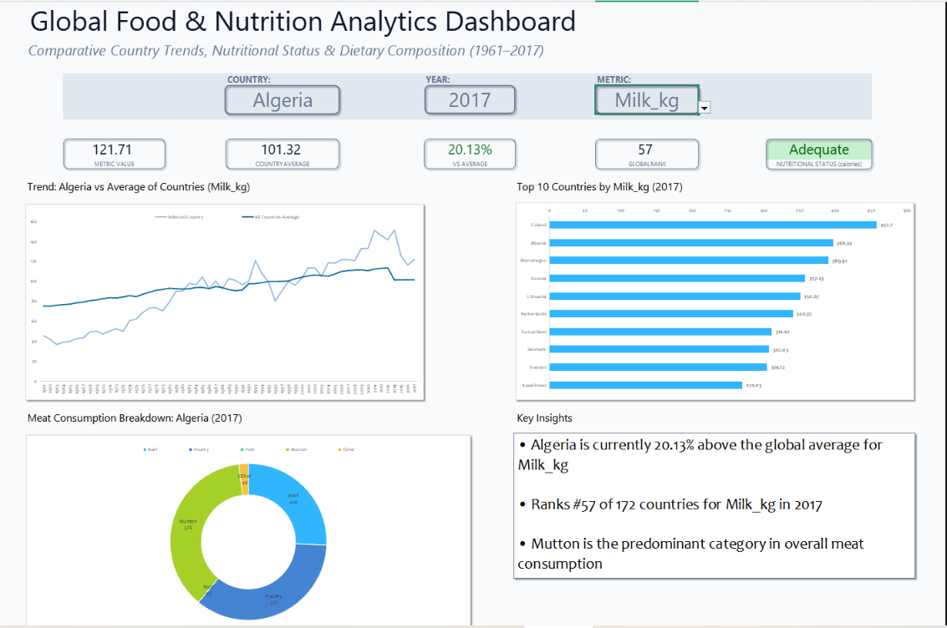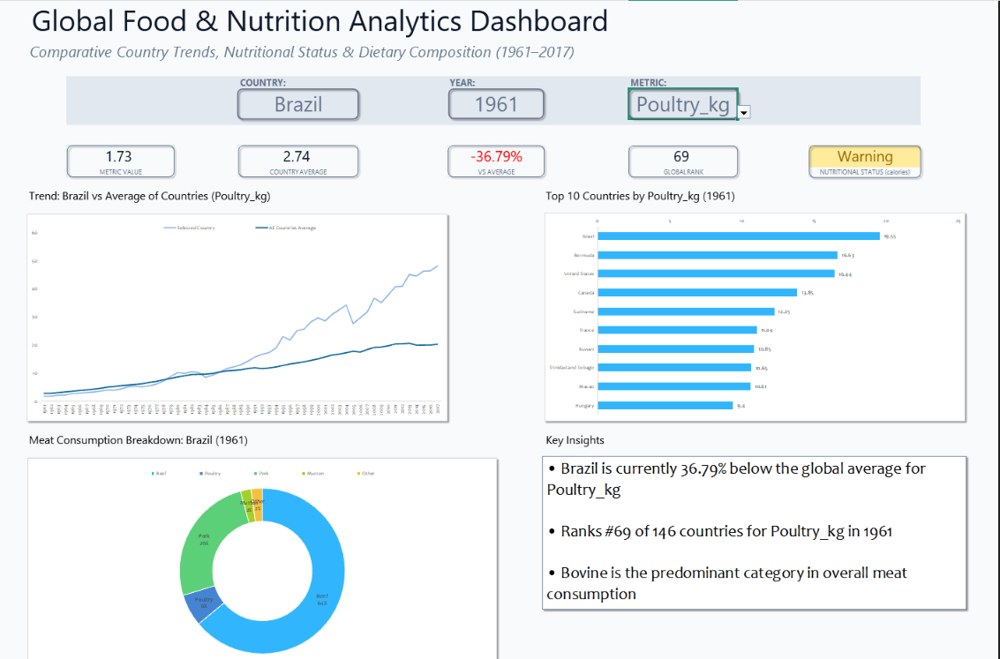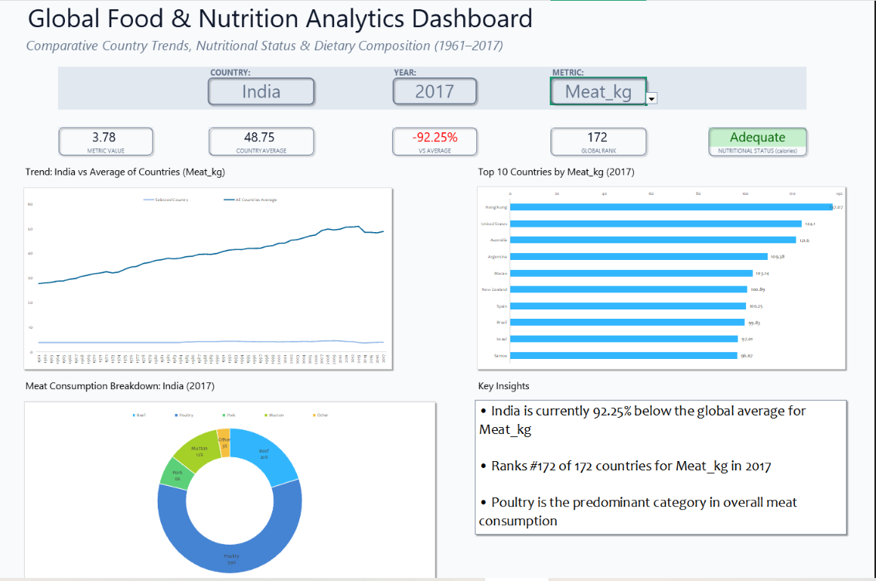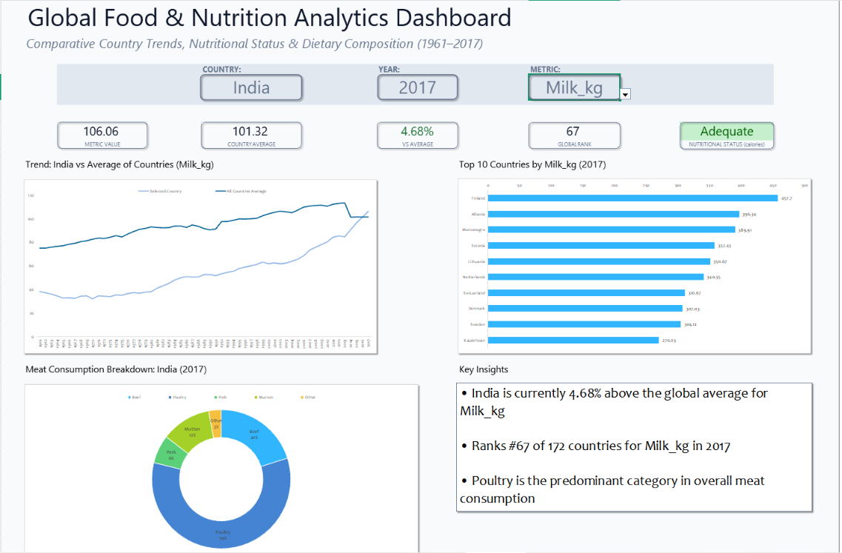
Test results screenshots
Figure 11. Scenario tests.

11. Limitations and Possible Improvements

Limitations
- Supply is not consumption. The data measures food available per person, not what people eat, and "country average" gives every country equal weight, whatever its size.
- "Global" means among countries with data. The rank is out of 146 to 172 countries depending on the year, not out of all countries in the world.
- The status reflects calories only, whichever metric is chosen, and its thresholds (2,100 and 2,500 kcal) are screening rules, not official classes.
- Dropdowns are independent. A user can pick a year in which the chosen country has no data. The dashboard handles this with a "No data" message, but a year list that adapts to the country would prevent it.
- Newer Excel is needed for the FILTER, XLOOKUP, and CHOOSECOLS formulas in the Key Insights box (Excel 365, 2021, or the web version).
- The data stops in 2017, so the dashboard cannot show recent changes.

Possible improvements
- Extend the rank highlight to the dashboard card. The gold top-10 rule is on the Calc cell (N5) and could also be applied to the card L9.
- A "compare with" dropdown adding a second country to the trend chart.
- A status-count chart showing how many countries are Severe, Warning, or Adequate in the chosen year.
- A year list that depends on the country (a dynamic named range using MINIFS and MAXIFS).
- A "show top N" control (5, 10, or 15) for the bar chart.

Appendix A: Formula Reference
Cell | Formula
tblFood[Metric_Value] | =IFERROR(INDEX(tblFood[[#This Row],[Calories_kcal]:[Veg_kg]], MATCH(Dashboard!$L$6, tblFood[[#Headers],[Calories_kcal]:[Veg_kg]], 0)), "")
tblFood[Rank_Key] | =IF(AND(tblFood[[#This Row],[Type]]="Country", tblFood[[#This Row],[Year]]=Dashboard!$I$6, ISNUMBER(tblFood[[#This Row],[Metric_Value]])), tblFood[[#This Row],[Metric_Value]] + ROW()/1000000000, "")
Calc!N2 (Value) | =IF(COUNTIFS(tblFood[Entity], Dashboard!$F$6, tblFood[Year], Dashboard!$I$6)=0, "No data", SUMIFS(tblFood[Metric_Value], tblFood[Entity], Dashboard!$F$6, tblFood[Year], Dashboard!$I$6))
Calc!N3 (Average) | =AVERAGEIFS(tblFood[Metric_Value], tblFood[Type], "Country", tblFood[Year], Dashboard!$I$6)
Calc!N4 | =IFERROR(Value/Average - 1, "No data")
Calc!N5 | =IF(ISNUMBER(N2), COUNTIFS(tblFood[Type], "Country", tblFood[Year], Dashboard!$I$6, tblFood[Metric_Value], ">"&N2) + 1, "No data")
Calc!N6 | =IFERROR(INDEX(tblFood[Nutritional_Status], MATCH(1, INDEX((tblFood[Entity]=Dashboard!$F$6)*(tblFood[Year]=Dashboard!$I$6), 0), 0)), "No data")
Calc!B2 | =IFERROR(AVERAGEIFS(tblFood[Metric_Value], tblFood[Entity], Dashboard!$F$6, tblFood[Year], A2), NA())
Calc!C2 | =IFERROR(AVERAGEIFS(tblFood[Metric_Value], tblFood[Type], "Country", tblFood[Year], A2), NA())
Calc!F2, G2, H2 | =LARGE(tblFood[Rank_Key], E2) | =INDEX(tblFood[Entity], MATCH(F2, tblFood[Rank_Key], 0)) | =INDEX(tblFood[Metric_Value], MATCH(F2, tblFood[Rank_Key], 0))
Calc!K2 to K6 | =SUMIFS(tblFood[Bovine_kg], tblFood[Entity], Dashboard!$F$6, tblFood[Year], Dashboard!$I$6), and the same for Poultry_kg, Pig_kg, Mutton_kg and OtherMeat_kg
Dashboard!C9, F9, I9, L9, O9 | =Calc!N2, =Calc!N3, =Calc!N4, =Calc!N5, =Calc!N6

Appendix B: Rebuild Checklist
- Copy the Week 3 workbook. Keep Raw_Data untouched.
- Add the sheets Lists, Calc and Dashboard.
- Fill the three lists and name them lstCountry, lstYear and lstMetric.
- Type default values in Dashboard F6, I6, and L6, then add the dropdowns with Data Validation.
- Add Metric_Value and Rank_Key to tblFood.
- Build the KPI, trend, top 10, and doughnut blocks on Calc, and name N2 and N3 as Value and Average.
- Insert the line, bar, and doughnut charts and move them to the Dashboard.
- Link the KPI cards, add the dynamic headings, and build the insight text box.
- Add the conditional formatting rules.
- Hide gridlines, set the zoom, and run the scenario tests.

